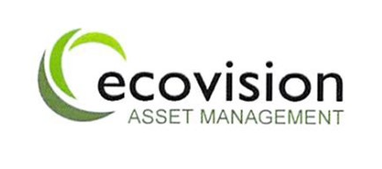
Stock and Warehouse Manager
Ecovision Asset Manager

Last Revised: 29th March 2022

Title: Stock and Warehouse Manager
Company: Ecovision Asset Management

About Ecovision Asset Management
Ecovision Asset Management has extensive experience in managing distributed rooftop solar PV asset portfolios across the UK. EAM currently manages in excess of 12,000 installations across the UK (38MWp capacity), primarily on behalf of large asset portfolio investors. The breadth of Ecovision’s solar PV asset management services enable our clients to maximise returns from their Solar PV assets whilst minimising operational costs.
Main purpose of the role:
Reporting to the Operations Manager, the main purpose will be to manage all areas relating to the Stroud Warehouse, stock (management, control, procurement, and distribution), and vehicles. You will be using your experience to set up standard warehouse and stock control procedures. Also, to support the Nationwide Engineer team, where appropriate. This role will suite a proactive, organised person who is able to put procedures in place and prioritise workload that facilitates excellent stock control and Nationwide distribution to engineers. This is a key role in a growing business, with great career opportunities for the right candidate.
Specific Responsibilities:
- Manage all areas of the Warehouse facility and procedures to operate, including, forklift maintenance, stock, organization of storage, waste disposal, security of building and contents.
- Stock management for the solar business, including, procurement, warranty, and distribution to field engineers.
- Management of all engineer equipment, including, ladder inspections and record keeping, electrical testing equipment and calibration, uniforms, Health and Safety equipment.
- Manage small van fleet, including signing vehicles in and out, service and maintenance.

Specific core competencies and skills:
- Highly organized and proactive
- Ability to evaluate approaches and implement improved processes and operational protocols, where required
- Current FLT license (preferred)
- IT literate
- Proficient driver of large vans

Experience and Person Specification
- Recent experience of running a warehouse (preferred)
- Can work well unsupervised
- Good working knowledge of Health and Safety in a warehouse environment
- Good stock management experience
- Trustworthy and reliable
- Logical thinker
- Works well under pressure
- Some experience of fleet management is preferred
- Some knowledge of Solar PV would be good but not essential

Additional Information
Travel: England, Wales, Scotland to support field engineers. Might include some overnight stays.

